Case 4-Eur-Sweden-Runic Calendar-1250 CE

The oldest discovered Runic calendar is the Nyköping staff from Sweden. Archaeologists and historians, think it is from the 13th century. Most Runic calendars are from the 16th and the 17th centuries.

Worm’s Norwegian runic calendar described in his book Fasti Danici dating back to 1643.

[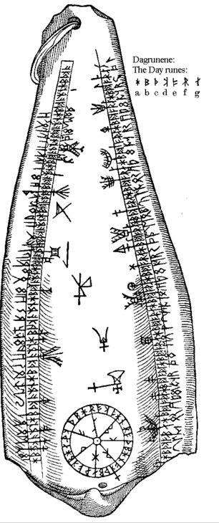](http://www.ancientpages.com/wp-content/uploads/2017/05/runiccalendar3.jpg)

The drawing only shows the winter season lasting from 14 October to 13 April. The summer season on the other side of the bone from a whale or big fish was never copied, and both the pendant and the calendar have unfortunately been lost.

[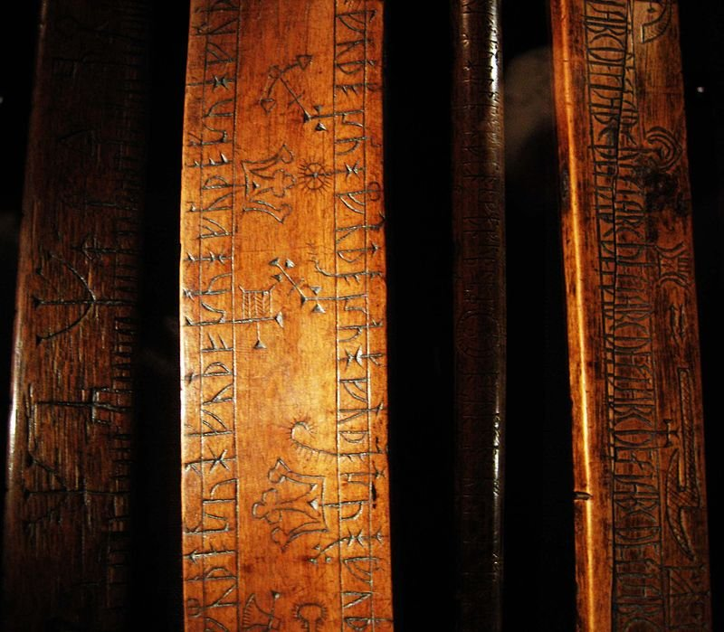](http://www.ancientpages.com/wp-content/uploads/2017/05/runiccalendar4.jpg)

This page is about the so-called Worms Norwegian run calendar described in his book Fasti Danici (ed. II, 1643), but also touches on primes, popular timing and anniversary tradition. Worms Norwegian run calendar is lost today, as repeated searches in Danish museums have not been possible to detect it. The run calendar is, according to Worm, shaken on a piece of bone that is probably the jawbone of a larger fish.  
  
Other suggestions that have emerged over the years, after studying Worm's drawing, are that the leg may be jawbone from a nise or a lower jaw of a medium-sized dental whale, for example. a killer whale, but the leg is crowned. As a look of the picture, the run calendar has a hole where a ring is attached. The ring has probably been to hang the calendar in.  
  
The picture shows only the winter's winter calendar (October 14 - April 13), and the summer season (April 14th - 13th of October), which has been sharpened on the back of the leg, Worm has unfortunately not made the trouble worth imitating, so the back cover of the calendar has gone lost. In other words, the run calendar is a kind of prime stick.  
  
The inscription, or calendar, begins at the wide end of the calendar, in this case 15th of October, and runs from left to right to 14th of January and continues from the wide end on the opposite side where it goes from right to left, where the calendar begins with January 15th and ending April 13th.  
  
For the first half of the year, October 14, there is a day-trip, but this is probably because a small piece of the leg is broken.  
  
At the top left of the calendar, a sign is partly on the line of the daycrafts and partly on the anniversary of the day after the day of January 14th, a sign that does not belong in any of these lines as an additional sign. The character is also available as additional characters in the outer rows. The meaning is uncertain, but in this case the sign may indicate that the inscription continues on the other side of the calendar. In any case, it is difficult to find other explanations as to why this sign has been scratched here.  
  
Runekalder Dagrunene  
The dawns, which they are called for the sake of brevity, have the same determination as otherwise in older calendars. Every weekday from January 1, its letter after the seven first is in the alphabet: A, B, C, D, E, F, G, but in this case the letter letters are marked as runes.  
  
A daydream is therefore no more mysterious than having to have a sign to mark the different days of the week in the calendar. The 7 day rides, one for each weekday, are repeated 26 times in the middle row on each side of the calendar.  
  
All weeks in a year that is not shooting year get the same letter / daydream for the weekdays all year. The diary of the first Sunday of the year will also be the diary of all other Sundays of that year. This was called the Sunday letter. In shooting year one must have two sunday letters, one before and one after 24 February.  
  
In the past, the Sunday letter was in the almanac, and we also find this system in calendars of various kinds before the Gregorian era was introduced. In some Swedish runic languages, we also find the seven first rounds from the younger runel language (fuktarkg) used instead of Latin letters.  
  
Brand Week  
The characters in the two inner rows on each side represent the half-year's different anniversaries. Anniversaries are for example. holidays, days when one should harvest or so etc.  
  
Sun circle, sun  
The 7 day rides are also found in the so-called sun circle, at the bottom of the calendar, which aims to determine the year's sunday runaway. The summer's calendar - ie the backside - should also have a similar circle, as Worms calls the moon circle. The moon circle has probably been the 19 golden numbers in natural order.  
  
The calendar year usually has 365 days, ie 52 weeks + 1 day. In the shooting year, the calendar year has 366 days, ie 52 weeks + 2 days. In ordinary years, the first and last days fall on the same weekday, January 1 on a Monday is also December 31, Monday. In the shooting year, the last day will be a weekday later, ie that on January 1, Monday will be 3l. December and Tuesday.  
  
After 28 years, after Christmas calendar calendar, New Year's Day and all other days of the year will be left on the same weekdays. This 28-year-old in the Julian calendar is called the Solar Circle (Cycle Solaris), and the number of the year in the solar circle is called the solar number.  
  
In the Middle Ages, the chronologists decided that the solar circle would take place during the firing year, where the first Sunday came on January 7th. We find sun circles on some Nordic primers.  
  
One can count towards the solstice by taking an annual number and dividing it by 28. To the answer, add one to 9, which is the solstice. Is the answer + the sum greater than 28, pulls a 28 from several times until one gets a response that is lower than 28, this answer is then the sun after the julian calendar.  
  
  
The golden numbers and the epact  
The two outer rows on each side show the golden numbers. The golden numbers are the numbers that tell the number of the year in the 19-year moon cycle. In the calendars they were placed on the data that the new moon will fall on every year in it 19-year cycle. In the beginning, golden numbers written with Roman numerals I-XIX in kalendrene.Etter that in the late Middle Ages began to introduce so-called "targeted" golden number, which would lead to the cyclical lunasjonene more consistent with the synodic, they utilized like to Arabic numerals to this . Such stylized Arabic numerals we find in some Norwegian prime spells, and likewise at Ole Worms whalebone calendar shown over.RunekalderGylllentallene inserted in the table to the left, has the function to display the day of the new moon falls on. New moon occurs every 29th or 30th day, but as you can see, there are only 19 golden numbers. The system is such that the golden age grows by 1 for each year and is determined by dividing the 19th century by adding 1 and adding 1 In this way, of course, there will be a few days without gold figures, but never two days in length. Of course, this does not mean that new moon can not fall on such days without gold numbers - one has only accepted an error that does not exceed more than one day. The Christian church took over the Julian calendar, which is a solar calendar. But many of the most important Christian festivals are determined by pattern after the Jewish moon calendar. The big spring and cleansing the party, passah, which is the Christian Easter, the holiday season Jews after the full moon that follows vårjevndøgn.I the Christian Church became the Memorial of Christ rose from the grave added to the Sunday after the full moon. This lunar bill will also have consequences for the other church feasts associated with Easter cycle, ie the time from Sunday septuagesima to treenighetssøndag.For church there was a lot to do to fix a long time in forvegen when Easter would fall year after year. For church use, a cyclical moon calendar was used, which based on the fact that 19 Julian years coincided with 235 nodical moons. The difference is only 0.618 days in a 19-year period. Only after approx. 380 years, the moon will come a day earlier than a cyclist had counted on. A month or synodic lunacy is about 29 days, 12 hours, 44 minutes and 2.98 seconds, ie 12 lunas last for about 354 days. Therefore, in one year there may be alternating 12 and 13 lunas. In ecclesiastical times the lunas were counted throughout the day so that they alternately were 29 and 30. In the 19th year 120 lunacies will be 30 days and 115 will be 29. In the shooting year, the February Union will receive 30 days. Of the 19 years, 7 will have 13 synodic lunations. Gold numbers In other calendars, the golden numbers are written as a so-called pentadic number series, which is based on the principle that each time the value has risen by five, a new symbol is entered. Printed, this golden age series will look like this in the picture above. This figure system is also found in English image calendars from the Middle Ages and in English calendars, the so-called clogs. Actually, this is the same as the Roman tallrekken.Gyllentall In continental calendars, and therefore also in the Nordic billedkalendrer which has its roots in the continental calendar tradition, we find another series of penta diske characters shown to venstre.Endelig must be mentioned that many hundreds of Swedish prime spells , the so-called runestars use runes for golden numbers. They have then made use of the 16 lanes in the younger runel font and constructed three new characters, making it 19 characters in total. Pact is a number that for each year in the 19-year-old moonlight gives the age of the moon how many days have passed from the last new moon at a certain date, epactarum is seen. As seen epactarum, one rained on March 22, the day after the church calendar's spring evenings. This year, the 19-year-old moonlight is the new moon on March 22, and this year has an epact of 0. The 12 lunas with alternating 29 and 30 days total 354 days. When the sun has 365 days, the moon's age II II on March 22 will be 11. If the number becomes greater than 30, one must deduct 30 from, because a lunatic can not be more than 30 days. For the 19 years under the lunar cycle will epakten be: Iiiiiiiiiii0 IIiiiiiiii11 IIIiiiiiii22 IViiiiii3 Viiii14VIiiiiii25 VIIiiiiiii6 VIIIiiii17 IXiiiii28 Xiiiiii9XIiiiiii20 XIIiiiiiii1 XIIIiiii12 XIViii23 XViii4XVIiii15 XVIIiii26 XVIIIiii7 XIXiii18